**Note:** +5V and GND should be provided either from the barrel connector (+12V converted to +5V), or the Mini-USB connector.

Connections between some components have not been fully defined/added yet, e.g. EBYTE-ATMEGA, GPS-ATMEGA.

**ATMEGA328P-AU**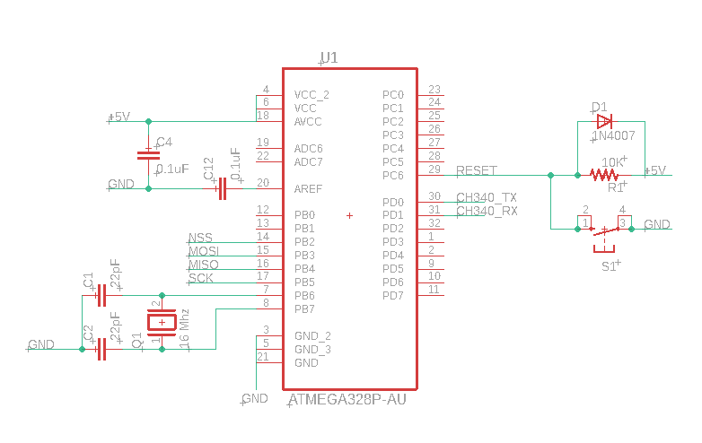This part is the ATMEGA328P (AU package). Has a 16MHz external oscillator (with 2 22pF capacitors), decoupling capacitors between VCC/AREF and GND. RESET pin by default is high (the +5V connection), but can also by connected to GND by the switch S1, the RESET of the ICSP (next), or DTR of the CH340G IC chip (later).

The ATMEGA requires +5V to safely run a 16MHz oscillator, and if only 3.3V is supplied, it should instead run an 8MHz oscillator.  
  
**ICSP**

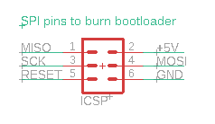

This 3x2 pin header connects to the SPI, +5V, GND, and RESET pins of the ATMEGA. Initially, the Arduino bootloader must be flashed in via SPI. Once this is done, it allows reprogramming via the USB port (using the CH340G as a serial-USB converter).

**CH340G**

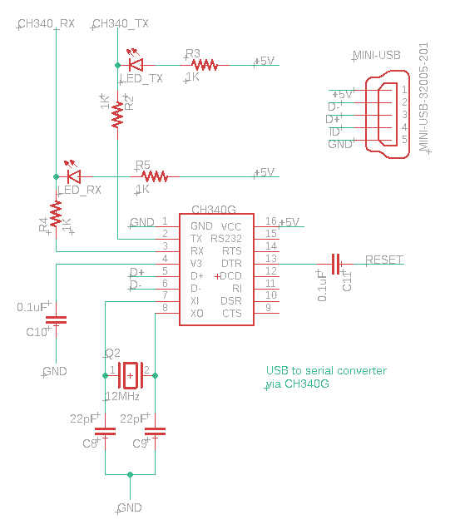

This part is used as a serial-USB converter to allow reprogramming via USB port after the Arduino bootloader has been flashed in. This part uses an external 12MHz crystal (with 2 22pF capacitors), LEDs for receive/transmit, DTR pin connected via 0.1uF capacitor to RESET of the ATMEGA. Additionally, to run in +5V operation mode, a 0.1uF capacitor is attached between V3 and GND, and +5V into VCC.

**Power LED**

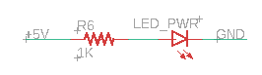

This part simply indicates whether the board is powered or not.

**DC DC converter**

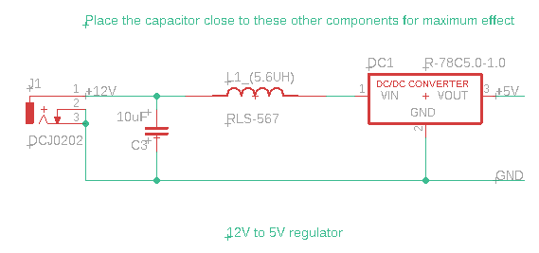

This section consists of the barrel connector (left) that receives +12V and GND, a 5.6uH choke (inductor), 10uF capacitor, and a RECOM DC/DC converter for +12V to +5V.

DC/DC converter datasheet (R-78C5.0-1.0 model used here in schematic): <https://recom-power.com/pdf/Innoline/R-78C-1.0.pdf>

Note Page 3 of the datasheet for EMC filter for EN55032. While it’s not a concern for us, and also LoRa apparently is rather immune to interference, I thought it would still be beneficial to try to filter it a bit since it is RF we’re dealing with (and also have a GPS, no idea how that will interact).

There should probably also be some decoupling capacitors as close to the +5V output as possible as there is the possibility of noise in the output (we want a stable +5V), due to the unpredictable timing of current draws (receive/transmitting of LoRa module)

**GPS module**

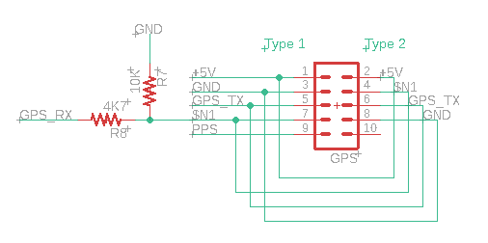

This section should provide 5x2 female pin header to allow GPS modules to be attached. Additionally, it allows for two different kinds of GPS modules to be attached for added compatibility.

The ATMEGA Tx-> GPS Rx uses resistors to drop the signal from +5V to +3.3V as required by the GPS module (we previously had it using +5V logic signals and it worked anyways, but this safely keeps it within specifications).

The modules it is created to take:

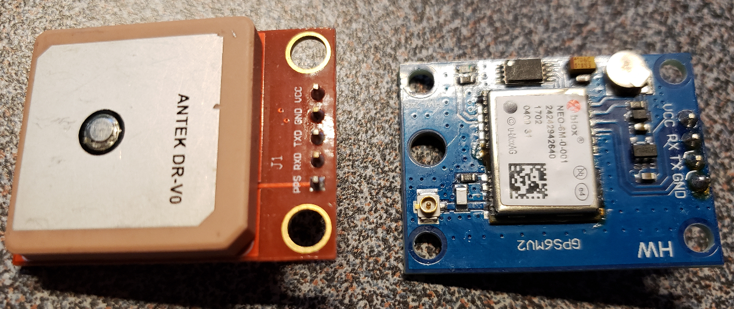

**LoRa module**

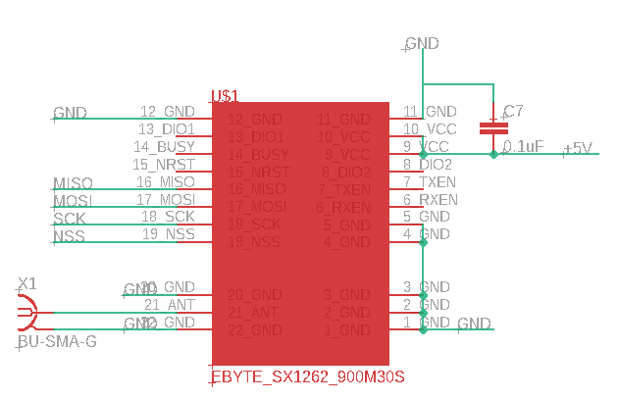

This LoRa module seems like a power hog. The transmission/receive parameters are configurable, but for operating at max transmission power (30-31DBi), it can draw up to 650mA during that period. Receiving data draws a relatively tiny amount at 14mA.

The SPI communications pins run at 3.3V rather than 5V, thus either need to convert the ATMEGAs digital pins to 3.3V (via logic level converter), or run it at 3.3V instead (and introduce another voltage regulator).

There should be a decoupling capacitor (is 0.1uF fine or no?) between VCC and GND due to the high transient current induced during transmission. We need a stable voltage/current during this period).

The main concern is whether the RECOM DC/DC converter chosen is able to safely support this module and the ATMEGA/GPS (if this only maxes at 650mA it is probably fine, I think we have a fair margin).